An approach to particle reduction using spherical harmonics expansion

S.B. Swanekamp, A.S. Richardson

Plasma Physics Division, Code 6771

Naval Research Laboratory

Washington, DC 20375

# **Introduction**

The solution to the Boltzmann equation is at the heart of plasma kinetic theory. Just about every plasma physics problem can be solved using the Boltzmann equation with an appropriately defined collision operator. One popular approach to solving the Boltzmann equation is to follow a number of sample particle orbits using the particle-in-cell (PIC) method.[[1]] Collisions are treated using the Monte-Carlo method (MCC) by sampling the various collisional cross sections at every time step.[[2],[3]] It can be shown that PIC/MCC simulations approach the solution to the Boltzmann equation as the number of sample particles increases. The PIC/MCC approach is a statistical method that often requires many thousands of particles per cell to adequately resolve both the energy and angular distribution of the electrons. For example, resolving an isotropic energy distribution with just 8 azimuthal zones and 8 polar zones and a modest 100 energies in velocity space requires 6,400 particles per cell. This is especially important in situations where the tail of the distribution is primarily responsible for the bulk of the ionization. Resolving the anisotropy in the electron distribution produced by electric and magnetic fields is also important for determining the plasma current. The statistical noise associated with resolving the distribution function in PIC/MCC simulations scales as $1/ \sqrt{N}$ where $N$ is the number of particles per cell. This means that a reduction in the statistical noise by a factor of two generally requires four times more particles. The demands on particle counts make accurate modeling of thermal plasma in complex 3D geometries with the PIC/MCC method computationally intensive and time consuming.

A difficulty that often arises with the PIC/MCC method occurs when the electric field reaches a critical value such that the Ohmically-heated plasma is hot enough produce a sizable ionization rate. This large ionization rate causes the plasma density grow exponentially in time. This causes the particle count in the PIC/MCC method to increase exponentially. This rapidly growing density quickly causes the number of computer particles to get so large that computer resources are exhausted and simulation progress grinds to a halt. Adaptive particle management (APM) algorithms which reduce the global particle number while simultaneously attempting to preserve the density, energy distribution, and particle drifts have been developed.[[4]] However, current APM algorithms focus on the preserving the energy distribution and a plasma drift without treating the angular distribution in velocity-space. This introduces errors in the velocity-space reconstruction which, in effect, introduces an artificial collisional drag that is difficult to quantify or detect. Another problem common to all APM methods is the loss of information lost caused when velocity-space distributions contained in the existing particles in the simulation are completely destroyed and then rebuilt with fewer particles. This loss of information is unavoidable and a quantification of this error is a very valuable. In this paper, an algorithm to reconstruct the both the energy and angular distribution of the velocity-space is presented. It is based on representing the the charged particle distribution function as an expansion series using spherical harmonic basis functions.

# **Spherical harmonics**

A low-temperature, collisional plasma is generally dominated by momentum-transfer collisions which tend to keep the plasma’s angular distribution nearly isotropic. Hydrodynamic and electromagnetic forces produce a small drift which gives rise to a velocity-space anisotropy which creates plasma current. This plasma current can be coupled to a Maxwell equation solver to provide self-consistent time and spatially varying electric and magnetic fields. Exploiting the nearly isotropic form for the distribution function can reduce the numerical overhead associated with solving the Boltzmann equation for highly collisional plasmas and lead to a very efficient algorithm for modeling kinetic effects. If the anisotropy is small, then the distribution function can be approximated by

When the angular distribution in velocity space is nearly isotropic, it is useful to represent the distribution function by a spherical harmonics series which can be written as

$$f\left(\vec{x},v,Ω\right)=\sum_{l=0}^{∞}{\sum_{m=-l}^{l}{\left(\frac{2l+1}{4π}\right)\frac{\left(l-m\right)!}{\left(l+m\right)!} P_{l}^{m}\left(μ\right)e^{imφ}f_{lm}\left(\vec{x},v\right)}} .$$ (1)

where $v$ is the speed, $Ω$ is the solid angle in velocity space with polar angle $θ$ and azimuthal angle $φ$, $P_{l}^{m}\left(μ\right)e^{imφ}$ are the unnormalized spherical harmonic functions, $P_{l}^{m}\left(μ\right)$ are the associated Legendre functions, $μ=cosθ$, and $f_{lm}$ are the complex expansion coefficients defined by

$$f_{l,m}\left(\vec{x},v\right)=\int{dΩ e^{-imφ}P_{l}^{m}\left(μ\right)f\left(\vec{x},v,Ω\right)} .$$ (2)

The differential velocity-space volume element is given by $d^{3}v=v^{2}dvdΩ$ where $dΩ=dμdφ$ is the differential solid-angle element. It is convenient to use the particle energy instead of the speed. Introducing an energy variable by $v=ηε^{1/2}$ where $η=\sqrt{2e/M}$ is a constant and $M$ is the particle mass. The factor of $e$ in the definition of $η$ means that the unit for $ε$ is $eV$. The normalization and orthogonality condition for the unnormalized spherical harmonics is given by

$$\int{dΩe^{-im^{'}φ}P_{l^{'}}^{m^{'}}\left(μ\right)P_{l}^{m}\left(μ\right)e^{imφ}=}\left(\frac{4π}{2k+1}\right)\frac{\left(k+n\right)!}{\left(k-n\right)!}δ_{l^{'},l}δ_{m^{'},m} ,$$

where $δ$ is the Kronecker delta function.

In this paper, we will primarily work with the electron speed, $v$, to derive equations. However, because cross-section information is usually provided in terms of electron energy in electron-volts ($eV)$, it is useful to define an energy variable by $ε={\left(v/η\right)}^{2}$ where $η=\sqrt{2e/m_{e}}$ is a constant. In terms of the energy variable, the velocity-space volume element can be expressed as $d^{3}v=\frac{1}{2}η^{3}ε^{1/2}dεdΩ$. The normalization of the electron distribution function in terms of the energy variable such that

$$n\left(\vec{x}\right)= \int_{0}^{∞}{dεε^{1/2}\int{dΩf\left(\vec{x},ε,Ω\right)}} .$$

where $N$ is the particle density. Substituting the spherical harmonic expansion for $f$ and using the orthogonality properties of $P_{l}^{m}\left(μ\right)e^{imφ}$, it can be shown that the density can be written as

$$n\left(\vec{x}\right)= \int_{0}^{∞}{dε ε^{1/2}f_{0}\left(\vec{x},ε\right)} .$$ (3)

where $f_{0}$ is the isotropic part of the distribution function. Equation (3) shows that $ε^{1/2}f_{0}$ can be interpreted as the density of particles with energies in $dε$ about $ε$. Equation (3) also shows that an APM that preserves the isotropic part of the distribution function conserves charge.

The average drift velocity of the particle can be calculated from

$$\vec{V}\left(\vec{x}\right)=\frac{1}{n}\int_{0}^{∞}{dεε^{1/2}\int{dΩ \vec{v}f\left(\vec{x},ε,Ω\right)}}=\frac{η}{n}\int_{0}^{∞}{dε ε{\vec{f}}_{1}\left(\vec{x},ε\right)}$$ (4)

where

$${\vec{f}}_{1}\left(\vec{x},ε\right)≡\int{dΩ}\hat{Ω}f\left(\vec{x},ε,Ω\right) .$$

and $\hat{Ω}=\vec{v}/v$ is a unit vector along the direction of $\vec{v}$. The current density is also of interest which is defined by

$$\vec{J}\left(\vec{x}\right)= Zen\left(\vec{x}\right)\vec{V}\left(\vec{x}\right)=Zeη\int_{0}^{∞}{dεε{\vec{f}}_{1}\left(\vec{x},ε\right)}$$ (5)

where $Z$ is the magnitude of the particle charge. It can be shown that ${\vec{f}}_{1}$ can be expressed entirely in terms of the $l=1$ terms in the spherical harmonic expansion. Equation (5) shows that an APM which preserves ${\vec{f}}_{1}$ will also preserve particle current. The average electron energy is defined by

$$〈ε〉=\frac{1}{n}\int_{0}^{∞}{dεε^{3/2}\int{dΩf\left(\vec{x},ε,Ω\right)}}=\frac{1}{n}\int_{0}^{∞}{dε ε^{3/2}f_{0}\left(\vec{x},ε\right)} .$$ (6)

By using $\vec{v}=\vec{v}-{\vec{V}}_{D}+{\vec{V}}_{D}$, it can be shown that

$$η^{2}〈ε〉=〈v^{2}〉=\left(〈{|\vec{v}-{\vec{V}}_{D}|}^{2}〉+2〈\vec{v}〉∙{\vec{V}}_{D}-V_{D}^{2}\right) .$$

Recognizing that $〈{|\vec{v}-{\vec{V}}_{D}|}^{2}〉=v_{th}^{2}$ and using $〈\vec{v}〉={\vec{V}}_{D}$, it can be shown that

$$η^{2}〈ε〉=v_{th}^{2}+V_{D}^{2}$$

Therefore, the isotropic distribution contains all the information needed to conserve energy. An APM that preserves $f_{0}$ also preserves the average energy per particle.

A highly collisional plasma is generally dominated by momentum-transfer collisions which tend to keep the plasma’s angular distribution nearly isotropic. Hydrodynamic and electromagnetic forces produce a small drift which gives rise to a small velocity-space anisotropy which creates plasma current. When the distribution function is nearly isotropic, only a few low-order terms in the spherical harmonic expansion are needed to provide a good representation for the distribution function. In many cases, only the first two terms are needed and it is possible to express the distribution function as

$$f\left(\vec{x},\vec{v}\right)≅\frac{f_{0}\left(\vec{x},ε\right)}{4π}+\frac{3}{4π}\left(\hat{Ω}∙{\vec{f}}_{1}\left(\vec{x},ε\right)\right)$$ (7)

Defining $α$ as the angle between $\hat{Ω}$ and ${\vec{f}}_{1}$, Eq. (8) can be rewritten as

$$f\left(\vec{x},\vec{v}\right)≅\frac{f_{0}\left(\vec{x},ε\right)}{4π}+\frac{3}{4π}\cos\left(α\right) f_{1}\left(\vec{x},ε\right)$$ (8)

where $f_{1}\left(\vec{x},ε\right)=\left|{\vec{f}}_{1}\right|$, $\cos\left(α\right)=\hat{Ω}∙{\hat{Ω}}_{D}$, and ${\hat{Ω}}_{D}={\vec{f}}_{1}/\left|{\vec{f}}_{1}\right|$ is unit vector in the direction of ${\vec{f}}_{1}$.

# **Accuracy of the two-term expansion**

In order to use Eq. (8) to rebuild the distribution function, it is important to first understand the source of the angular behavior of each term in this equation. The isotropic term represents a distribution that is independent of angle such that, at each energy, there is a large number of particles that share a common energy but with a direction vector that is uniformly distributed on the unit sphere. If $v_{0}=ηε_{0}^{1/2}$ is a speed, then the isotropic velocity vector is ${\vec{v}}_{0}=v_{0}\hat{Ω}$. The the tips of the velocity vectors of all the particles moving with that speed obtained from an isotropic distribution trace out a sphere of radius $v_{0}$ in velocity space. Figure 1a) shows a slice of the unit sphere through the $v_{x}-v_{z}$ plane and a sample particle moving with speed $v_{0}$ in that plane. In this plane, the velocity vectors of the particles with an isotropic distribution moving with speed $v_{0}$ trace out the black circle.

The second term in Eq. (8) arises from a drift that translates the isotropic distribution along the direction of the drift. The red circle in Fig. 1a) is a shift of the isotropic vectors by an amount $v_{D}$ along the $v_{z}-$ axis. The velocity vectors for the shifted velocity are all shifted along the direction and given by

$$\vec{v}=v_{0}\hat{Ω}+{\vec{v}}_{D}$$ (9)

The speed of the drifting particles is

$$v=\sqrt{v_{0}^{2}+2v_{0}v_{D}cosα+v_{D}^{2}}≅v_{0}+v_{D}cosα$$ (10)

where $α$ is the angle between ${\vec{v}}_{0}$ and ${\vec{v}}_{D}$ and a term of order ${\left(v_{D}/v_{0}\right)}^{2}$ has been dropped in the approximate expression. A comparison of the exact speed of the drifting particle for $v_{D}/v_{0}=0.2$ with the speed obtained from Eq. (10) is shown in Fig. 2a. This shows that the particle drift introduces a modulation on the isotropic speed that is nearly sinusoidal. The error incurred when using Eq. (10) for several values of $v_{D}/v_{0}$ is shown in Fig. 2b. This figure shows that the error incurred by using Eq. (10) to estimate the speed of the drifting particle is less than $5\%$ for drift speeds as high as $v_{D}/v_{0}=0.3$.

For a distribution with a small drift component, it can be shown that

$$f\left(v,Ω\right)≅f\left(v_{0}+v_{D}cosα\right)≅\frac{1}{4π}f_{0}\left(v_{0}\right)+\frac{3}{4π}cosα f_{1}\left(v_{0}\right)$$

where $f_{1}$ is of order $v_{D}/v_{0}$ and the coefficients are chosen so that the distribution satisfies Eq. (2). This shows that the second term Eq. (8) can be interpreted as a small correction to an isotropic distribution due to a velocity drift. The most familiar distribution is a drifting Maxwellian distribution given by

$$f_{M}\left(\vec{v}\right)=A e^{-\frac{\left(v^{2}+V_{D}^{2}\right)}{v_{th}^{2}}}e^{\frac{2vV_{D}}{v_{th}^{2}}cosθ}$$

where $A=\frac{n}{{\left(2πv_{th}^{2}\right)}^{3/2}}$ a normalization constant, $v_{th}$ is the thermal speed, the drift is assumed to be along the $v_{z}-$ axis, and $θ$ is the angle between $\vec{v}$ and the $v_{z}-$ axis. Using this distribution, it can be shown that the distributions $f_{0}\left(v\right)$ and $f_{1}\left(v\right)$ are given by

$$\frac{1}{4π}f_{0}\left(v\right)=A\frac{v_{th}^{2}}{vV_{D} }\frac{1}{4}\left(e^{-\frac{{\left(v-V_{D}\right)}^{2}}{v_{th}^{2}}}-e^{-\frac{{\left(v+V_{D}\right)}^{2}}{v_{th}^{2}}}\right)$$

$$\frac{3}{4π}f_{1}\left(v\right)=-A{\left(\frac{v_{th}^{2}}{vV_{D} }\right)}^{2}\frac{3}{8}\left(\left(1-2\frac{vV_{D}}{ v_{th}^{2}}\right)e^{-\frac{{\left(v-V_{D}\right)}^{2}}{v_{th}^{2}}}-\left(1+2\frac{vV_{D}}{ v_{th}^{2}}\right)e^{-\frac{{\left(v+V_{D}\right)}^{2}}{v_{th}^{2}}}\right)$$

A plot of the distributions $f_{0}\left(v\right)$ and $f_{1}\left(v\right)$ for $V_{D}/v_{th}=0.2$ are shown in Fig. 3a. These distributions can be used to build the two-term approximation given by Eq. (8). A comparison between the exact drifting Maxwellian and the two-term approximation for $V_{D}/v_{th}=0.2$ is shown in Fig. 3b. This shows that the two-term approximation is a very good estimate of the actual distribution. The error incurred when representing the distribution by the two-term approximation can be estimated by

$$error=\left|f_{M}-\left(\frac{1}{4π}f_{0}+\frac{3}{4π}cosα f_{1}\right)\right|$$

A contour plot of the error for $V_{D}/v_{th}=0.2$, shown in Fig. 4a, demonstrates that the error is less than 2% for this choice of $V_{D}/v_{th}$. This error increases to 8% as the magnitude of the drift increases to $V_{D}/v_{th}=0.4$. This behavior is to be expected since the angular distribution becomes more beam-like as $V_{D}$ becomes large compared to $v_{th}$. When $V_{D}\sim v_{th}$, the distribution becomes highly anisotropic and many more terms than just the first two terms are needed in the spherical harmonic expansion. However, as more terms are added to the expansion, the density and energy are still determined from $f_{0}$ using Eqs. (3) and (6) and the drift velocity is still determined from $f_{1}$ using Eq. (4).

# **APM using the two-term expansion**

When the two-term approximation is valid, Eq. (9) can be used to reconstruct the velocity-space distribution with appropriately chosen values for the isotropic speed and the magnitude and direction for the drift velocity. These values must come by appropriately sampling the distributions $f_{0}\left(\vec{x},ε\right)$ and ${\vec{f}}_{1}\left(\vec{x},ε\right)$ which are obtained by gathering information from the positions and velocities of the existing particles in the simulation to grid locations. It is important that $f_{0}\left(\vec{x},ε\right)$ be determined at grid locations where density is normally accumulated. It is determined by gathering all the particles that contribute to the density at the grid point and creating a histogram of the energy distribution of these particles. When done properly, it should be possible to use Eq. (3) to compute the density at each grid location to round off error from the energy histogram. The ${\vec{f}}_{1}$ distribution is accumulated at grid locations where the current density is normally gathered. It is determined by gathering all the particles that contribute to the current density, weighting each particle by its velocity direction vector, ${\vec{v}}_{p}/v_{p}$, and then creating an energy histogram. It is important that ${\vec{f}}_{1}$ be built from the same group of particles that contribute the current density at each grid location using the same allocation algorithm used to acquire the current density. When done properly, it should be possible to use Eq. (5) to compute the current density at each grid location to round off error from this weighted energy histogram.

The $f_{0}$ and ${\vec{f}}_{1}$ distributions that have been accumulated on the grid are then interpolated to the spatial location where it is desired to rebuild the distribution function. If is the position within the cell where the distribution function is to be reconstructed, then the distribution function at that point is given by

(11)

where and are the distributions interpolated from the grid values. It is important to note that the interpolating functions used to interpolate the grid quantities to the position ${\vec{x}}_{k}$ must be identical to that used to gather the grid quantities from the particle positions and velocities.

Eq. (8) can be exploited to reconstruct the particle distribution from an existing group of particles. The idea is to use the positions and velocities of the existing particles in the simulation to accumulate the distributions $f_{0}\left(\vec{x},ε\right)$ and ${\vec{f}}_{1}\left(\vec{x},ε\right)$ at the natural locations on the grid where the charge density and current density are accumulated. The new positions and velocities are then obtained by sampling Eq. (8). If ${\vec{x}}_{i}$ is the position of a node where charge density is normally accumulated, then $f_{0}\left({\vec{x}}_{i},ε\right)$ is found by gathering all the particles that contribute to the density at ${\vec{x}}_{i}$ and binning them up with respect to their energy. If ${\vec{x}}_{i}'$ is the position of a node where charge density is normally accumulated, then ${\vec{f}}_{1}\left({\vec{x}}_{i}',ε\right)$ is found by gathering all the particles that contribute to the current density at ${\vec{x}}_{i}'$, weighting them by their velocity direction vectors, ${\vec{v}}_{k}/v_{k}$, and then binning them up with respect to their energy. It is important that the same allocation algorithm be used to accumulate current density be used to accumulate ${\vec{f}}_{1}$ so that it is built from the exact same group of particles that contribute to $\vec{J}\left({\vec{x}}_{i}'\right)$. If done correctly, it should be possible to compute the current density from $\vec{J}\left({\vec{x}}_{i}'\right)= Zeη\int_{0}^{∞}{dεε{\vec{f}}_{1}\left({\vec{x}}_{i}',ε\right)}$.

The $f_{0}$ and ${\vec{f}}_{1}$ distributions that have been accumulated on the grid are then interpolated to the spatial location where it is desired to rebuild the distribution function. If is the position within the cell where the distribution function is to be reconstructed, then the distribution function at that point is given by

(11)

where and are the distributions interpolated from the grid values. It is important to note that the interpolating functions used to interpolate the grid quantities to the position ${\vec{x}}_{k}$ must be identical to that used during the functions used to gather the grid quantities.

To rebuild the distribution, the unit sphere is first divided into a grid with the center of each cell giving a unit direction vector. In the algorithm, it is important that the grid for the unit sphere be symmetric so that the unit vector associated with each cell has the one diametrically opposed also included. This will be important when rebuilding the isotropic part of the distribution. Along each unit vector direction, the electron energy is sampled from the conditional probability of finding a particle with energy $ε$ along each direction. If ${\hat{Ω}}_{j}$ is a unit vector along one of the direction on the sphere, then this probability is defined by

$$f\left({\vec{x}}_{k},ε|Ω_{j}\right)=4π f\left({\vec{x}}_{k},ε,Ω_{j}\right)/p_{k}\left(Ω_{j}\right)$$

where $p_{k}\left(Ω_{j}\right)$ is the probability of finding a particle in the direction ${\hat{Ω}}_{j}$ independent of the particle energy which is given by

$$p_{k}\left(Ω_{j}\right)=4π\int_{0}^{∞}{dεε^{1/2}f\left({\vec{x}}_{k},ε,Ω_{j}\right)}=N\left({\vec{x}}_{k}\right)+3{\hat{Ω}}_{j}∙\int_{0}^{∞}{dεε^{1/2}{\vec{f}}_{1}\left(\vec{x},ε\right)} .$$

The particle energy can be determined by obtaining a random number, $ξ$, and then inverting the following equation

$$ξ=\int_{0}^{ε}{dεε^{1/2}f\left({\vec{x}}_{k},ε|Ω_{j}\right)}$$

to obtain $ε$. It is also useful to know which part of the particle energy, $ε_{0}$, came from the isotropic distribution. This can be determined from

$$ξ=\frac{1}{N}\int_{0}^{ε_{0}}{dεε^{1/2}f_{0}\left({\vec{x}}_{k},ε\right)}$$

$$v=ε_{0}$$

Let $N_{φ}$ and $N_{μ}$ represent the number of azimuthal and polar bins and $N_{ε}$ represents the number of energy. A equal-weight particle will be put in each of the bins. If $V_{k}$ is the volume element associated with ${\vec{x}}_{k}$, then $W_{k}=V_{k}N\left({\vec{x}}_{k}\right)$ is the total particle weight of the existing particle distribution. The density, $N\left({\vec{x}}_{k}\right)$, can be determined either by interpolating from the density grid of calculated directly from $f_{0}\left({\vec{x}}_{k},ε\right)$ using $N\left({\vec{x}}_{k}\right)=\int_{0}^{∞}{dε ε^{1/2}f_{0}\left({\vec{x}}_{k},ε\right)}$. The particle weights are determined from $w_{k,i}=W_{k}/N_{p}$ where $N_{p}=N_{φ}N_{μ}N_{ε}$ is the number of particles in the reconstructed distribution.

The APM then samples the distribution in Eq. (12) to place a particle in each of the bins. However, care must be exercised to ensure that the angular distributions The means that special sampling techniques must be used for the angular

If ${\vec{x}}_{k}$ is the spatial location where the distribution is to be rebuilt and $V_{k}$ is the spatial volume element associated with that location, then $W_{k}=V_{k}N\left({\vec{x}}_{k}\right)$ is the total particle weight of the existing particle distribution. The density can be obtained by either interpolating the density from the grid or calculated directly from $f_{0}\left({\vec{x}}_{k},ε\right)$ using $N\left({\vec{x}}_{k}\right)=\int_{0}^{∞}{dε ε^{1/2}f_{0}\left({\vec{x}}_{k},ε\right)}$. The distribution function reconstruction should preserve the total particle weight and the APM method described here will use particles with equal weights $w_{k,i}=W_{k}/N_{p}$ where $N_{p}$ is the number of particles in the reconstructed distribution.

One of the difficulties with coupling APM methods to electromagnetic PIC codes is that they must not introduce charge conservation errors. These charge conservation errors can produce spurious, non-physical electromagnetic fields that produce errors in the kinetics. This means that special care must be made to assure that the APM does not introduce any new charges or currents other than those present in the original particles distribution. Most modern PIC codes enforce charge conservation using a charge-conserving current allocation algorithm that enforces the continuity equation.[[5]] The most common method The difficulty associated with reconstructing the particle distributions from the existing particles is that the charge and current associated with a group of particles must be preserved. This is desirable since charge and current errors introduce an unphysical source term into the continuity equation.

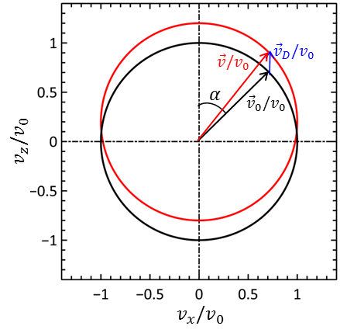

Figure 1. The velocity-space distribution represented by Eq. (8) for a drift along the $v_{z}-$ axis.

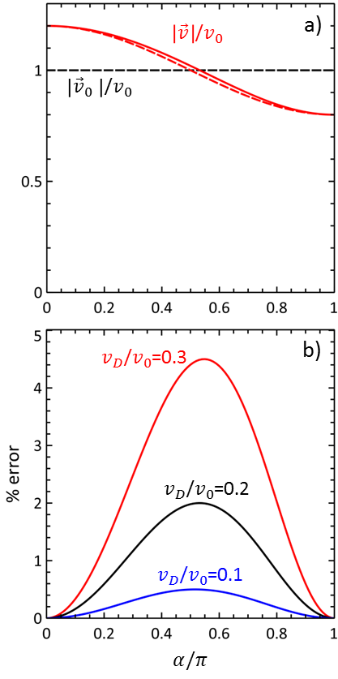

Figure 2. a) The particle speed as a function of the angle $θ$ for $v_{D}/v_{0}=0.2$. The dash curve shows the accuracy of the approximation $v/v_{0}≅1+0.2cosα$. b) The percent error incurred by the approximation $v≅v_{0}+v_{D}cosα$ for $v_{D}/v_{0}=0.1, 0.2,$ and $0.3$.

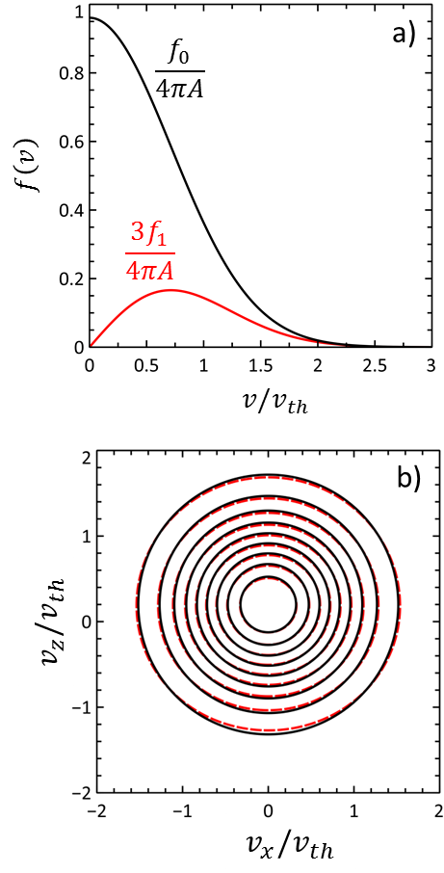

Figure 3. a) The $f_{0}$ and $f_{1}$ distributions for a drifting Maxwellian for $V_{D}/v_{th}=0.2$. b) A comparison of the drifting Maxwellian distribution (solid black) and the approximation given by Eq. (8) (red dashes) for $V_{D}/v_{th}=0.2$.

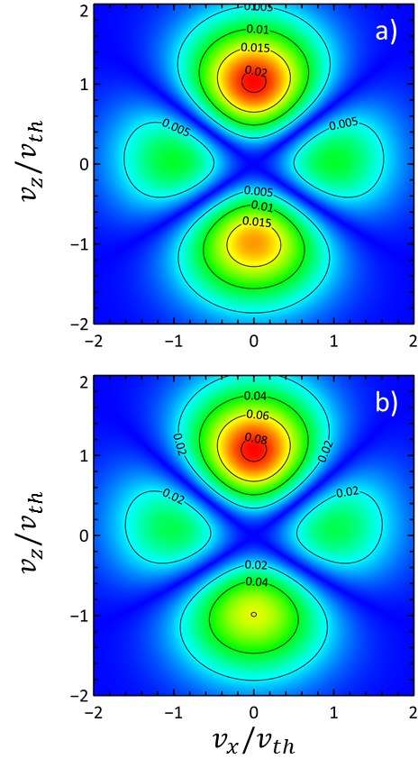

Figure 4. Contours of the absolute value of the difference between a drifting Maxwellian and the two-term approximation for a) $V_{D}/v_{th}=0.2$ and b) $V_{D}/v_{th}=0.4$.

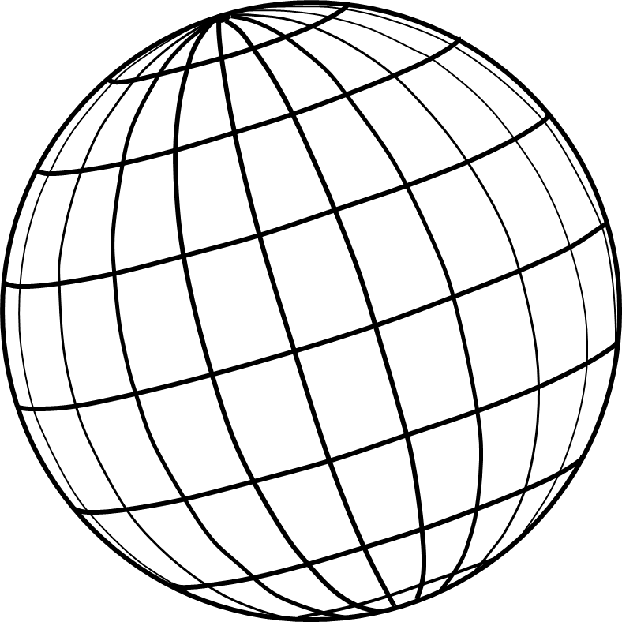

Figure 5. The unit sphere with discretized by grid of points.

1. [] C.K. Birdsall, *Plasma physics via computer simulation*, Adam Higler, New York (1991).
2. [] C.K. Birdsall, *Particle-in-cell charged-particle simulations, plus Monte Carlo collisions with neutral atoms, PIC-MCC*, IEEE Trans. Plasma Sci. **19,** 65 (1991).
3. [] V. Vahedi and M. Surendra, *A Monte Carlo collision model for the particle-in-cell method: applications to argon and oxygen discharges*, Computer Physics Communications **87**, 179 (1995).
4. [] D.R. Welch, T.C. Genoni, R.E. Clark, D.V. Rose, *Adaptive particle management in a particle-in-cell code*, J. Comp. Physics **227**, 143 (2007).
5. [] J. Villasenor and O. Buneman, *Rigorous charge conservation for local electromagnetic field solvers*, Computer Physics Communications **69**, 306 (1992).